Overview of Registration and Login page:

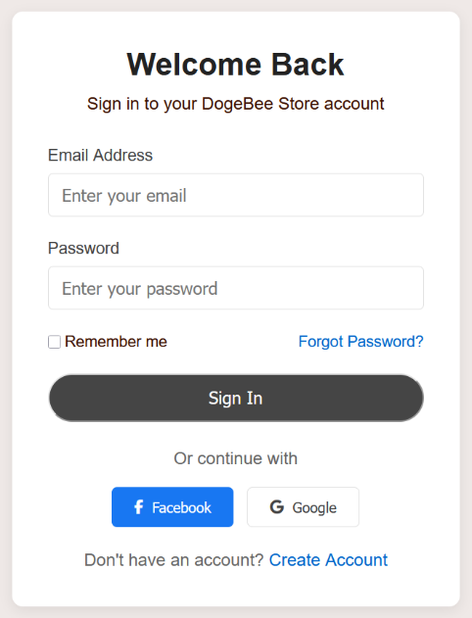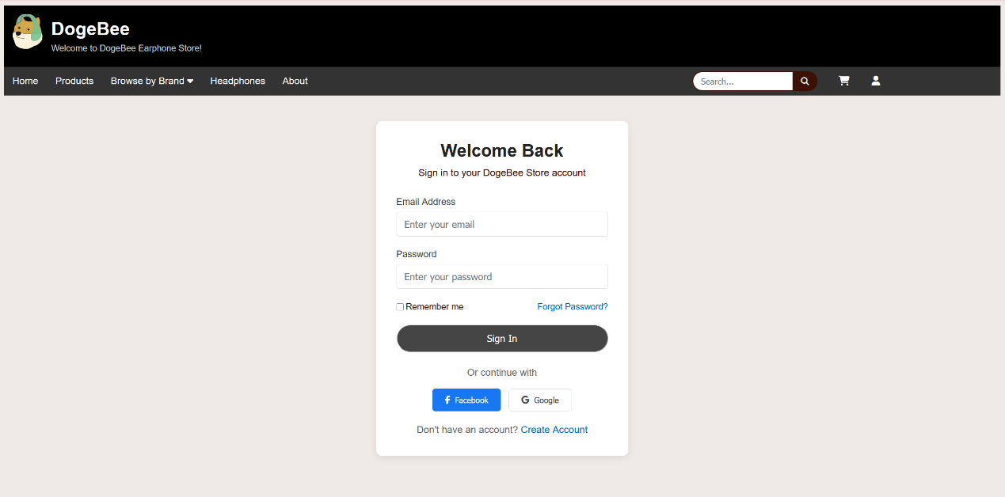

LOGIN: Register: 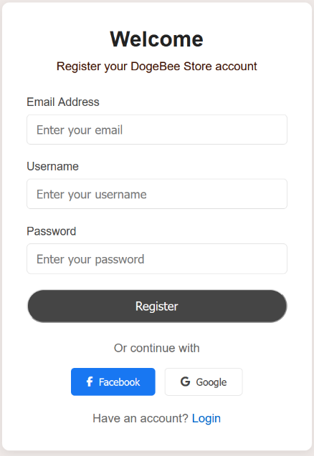

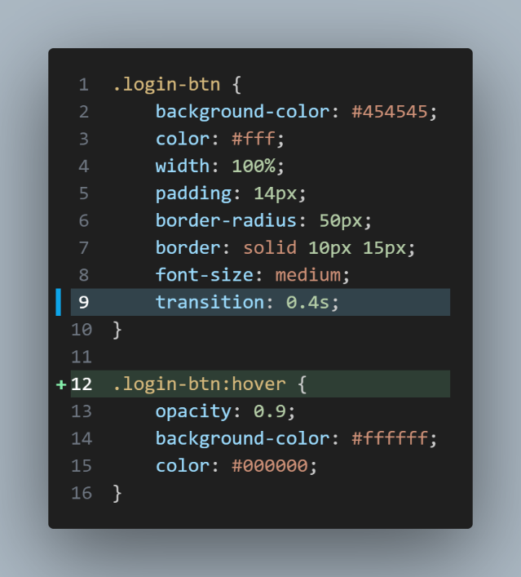Code:

The Sign in and register button contain a transaction when hovers on them.

The duration of the ransaction is 0.4s while the background colour turns white and the text colour turns black.

Overview of Login Page HTML:

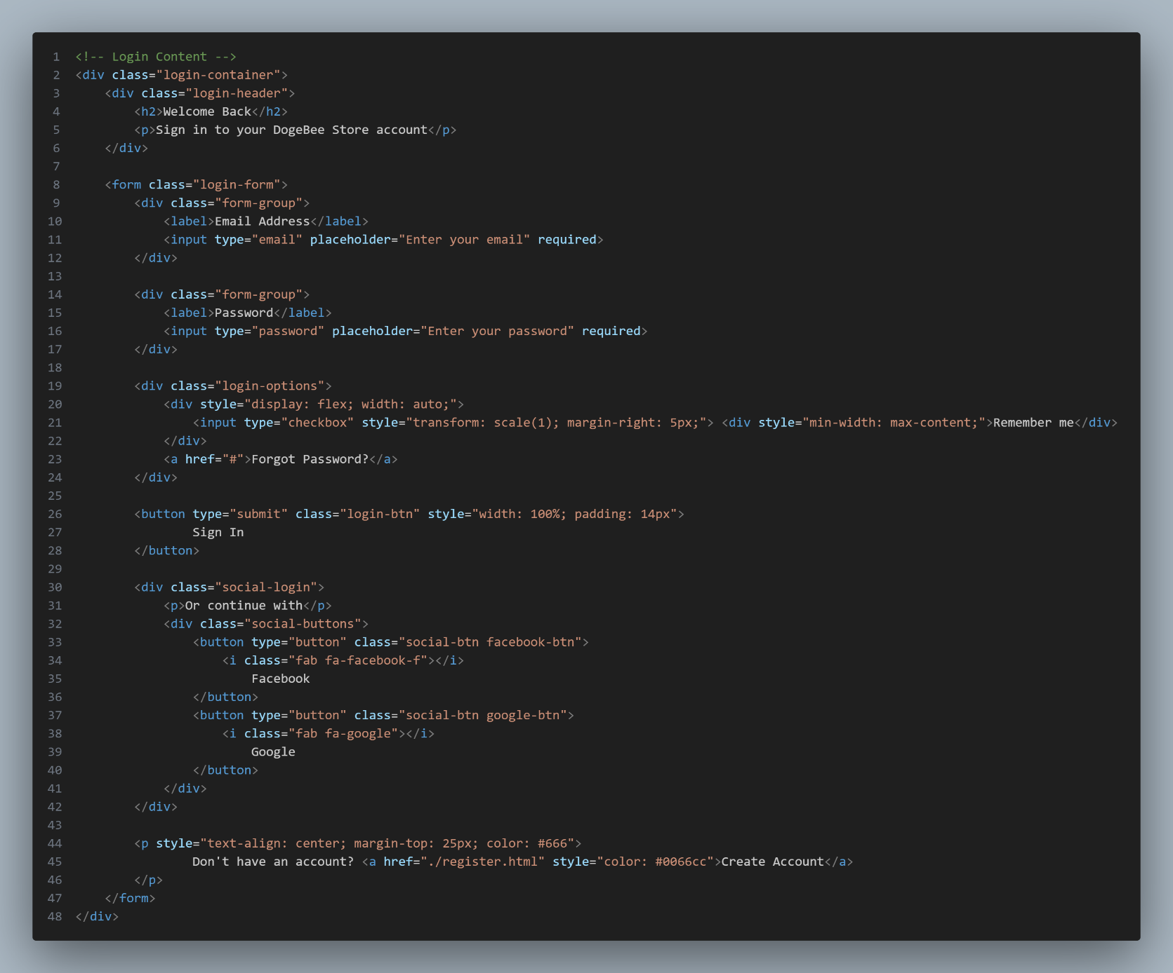

Users Account Database Structure: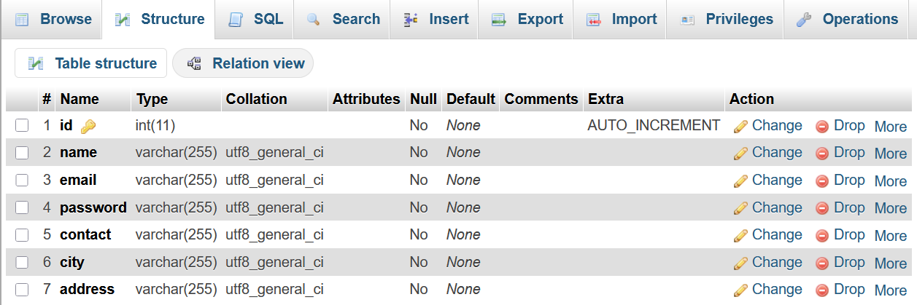

Example of an user data inserted in the database:

